PHP website portfolio

Design

.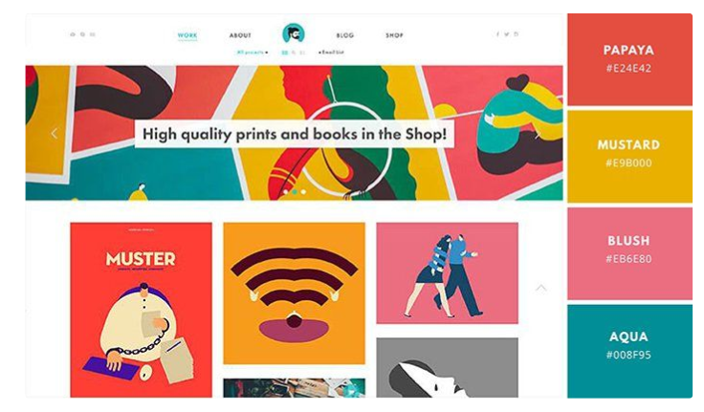

To do

home page - funky all in one scroll - see uidesignpatterns for ideas

about, show api's

tickets - show functionality with php and refinement searching

to do list:

sort out navbar

sort out landing page

begin php for searching for properties

- main design

- on session timeout logout user

- create header page and import rather than have it on each page

- go through log in and ensure it is understood

- redesign the login page